**Import the Moodlight-Template Project into Simplicity Studio Workspace**

eand 3.9.2019

1. Start Simplicity Studio
2. Open the Simplicity IDE  
   If the Simplicity IDE symbol is not shown in the main menu bar on the top of the Launcher perspective, try the following:  
   - Click on the Open Perspective symbol

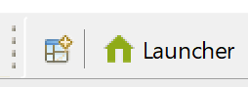

* and select Simplicity IDE

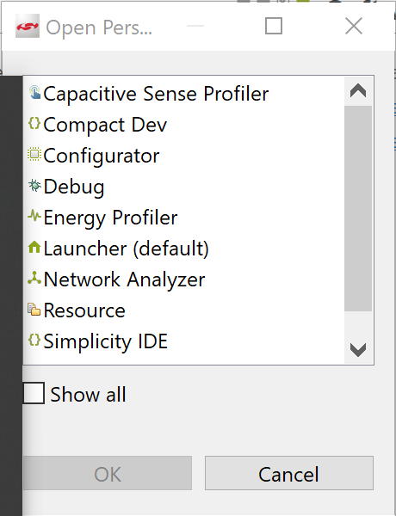

1. In the Simplicity IDE perspective, choose “File 🡪 Import” from the menu bar.
2. From the “Import Project” window, follow the link “More Import Options”   
   (on the bottom left) :  
   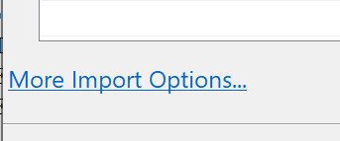
3. From the “Import” window, select “General🡪Existing Projects into Workspace” and click “Next”.  
   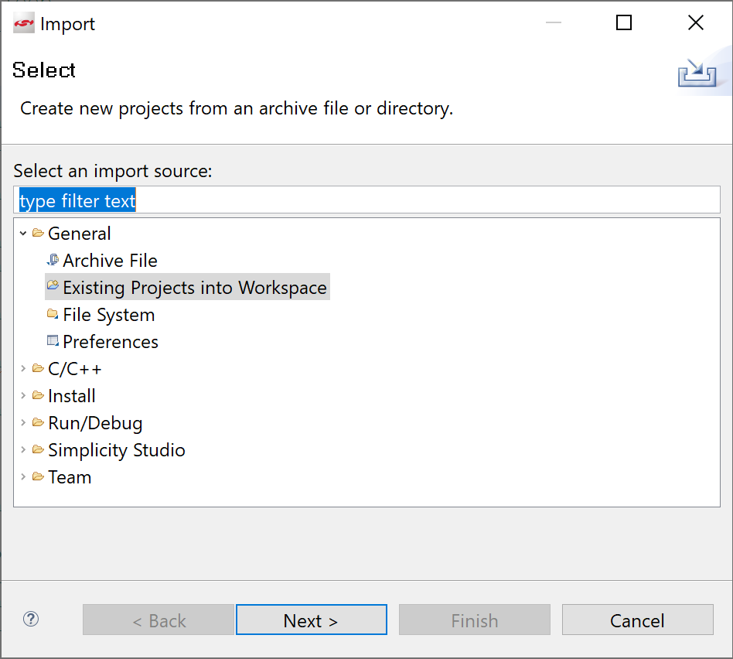
4. Activate “Select archive file” and using the Browse… button enter the location of Moodlight-Template zip file, which is found in the ETP pool directory:   
   //shared.zhaw.ch/pools/t/T-ZSN-ETP/Gecko_SW/for_SimplicityStudio_v4  
   Select the zip file: MoodLight_Template_SDKxxx.zip *  
   and finally press Finish.  
   *Note: xxx stands for the SDK version, this may change depending on SDK updates.

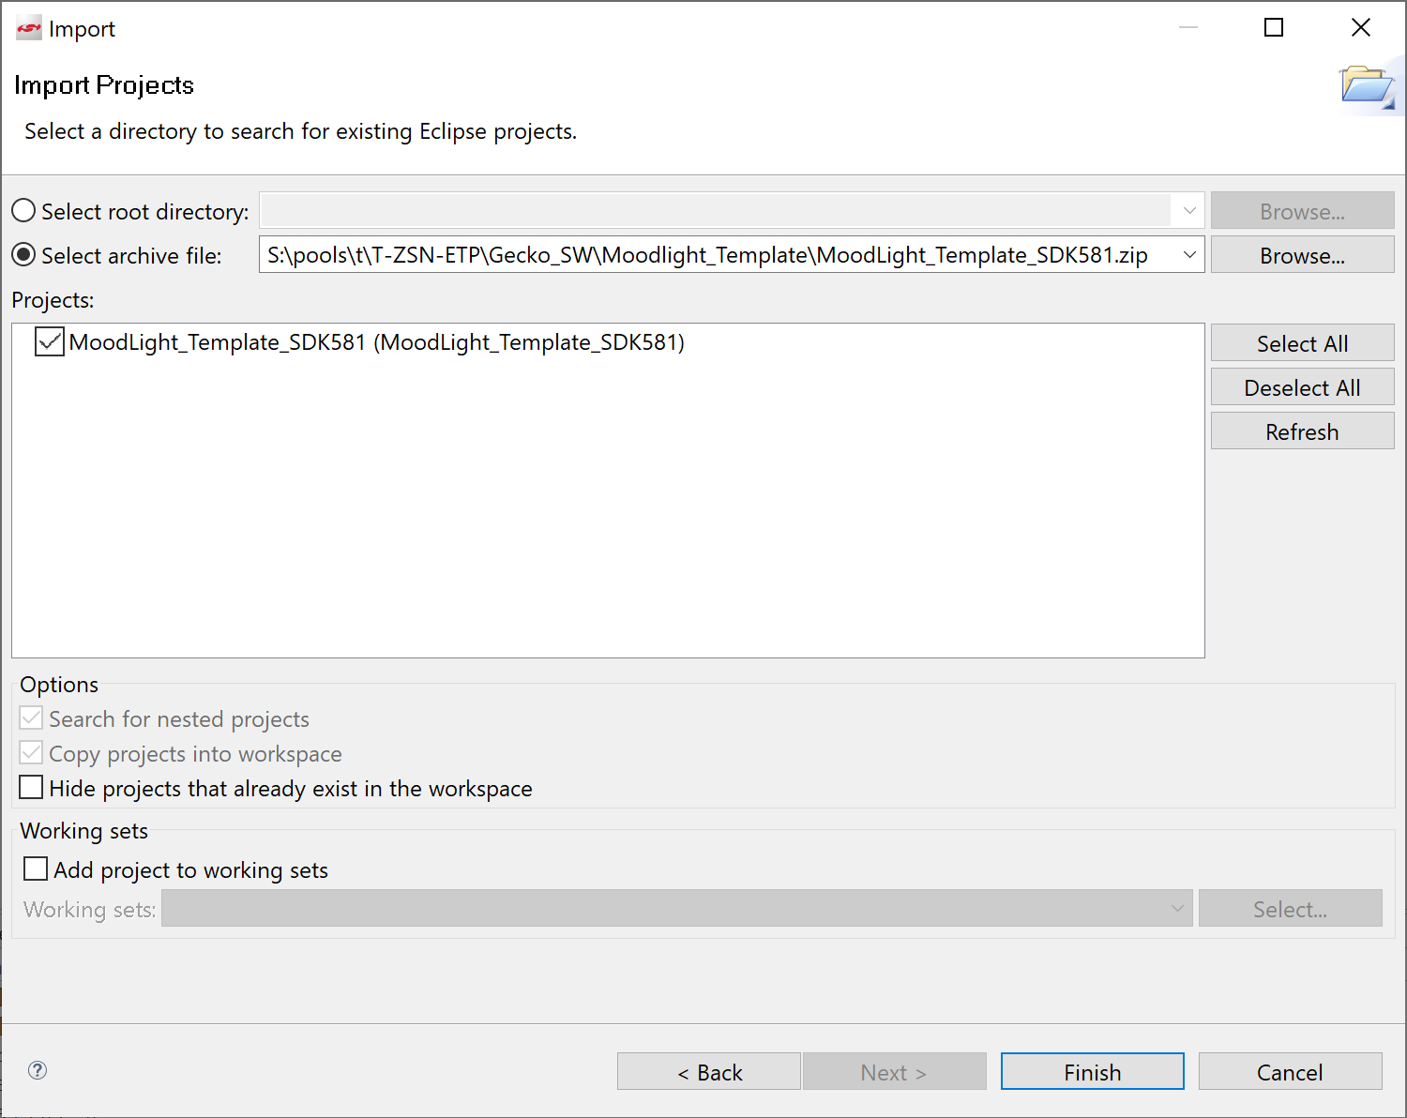

1. The Moodlight Template project is now imported into the workspace and can be used within the Simplicity IDE.  
   To build and run this program in debug mode, connect the STK board via USB and click on the debug icon in the menu bar of the IDE: MoodLight_Template_SDK581

MoodLight_Template_SDK581

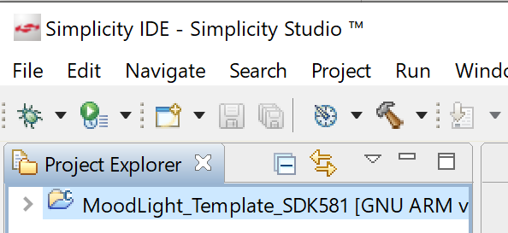

1. The program is rebuilt and the executables are uploaded in into the STK. When successfully finished, the Debug perspective is automatically opened

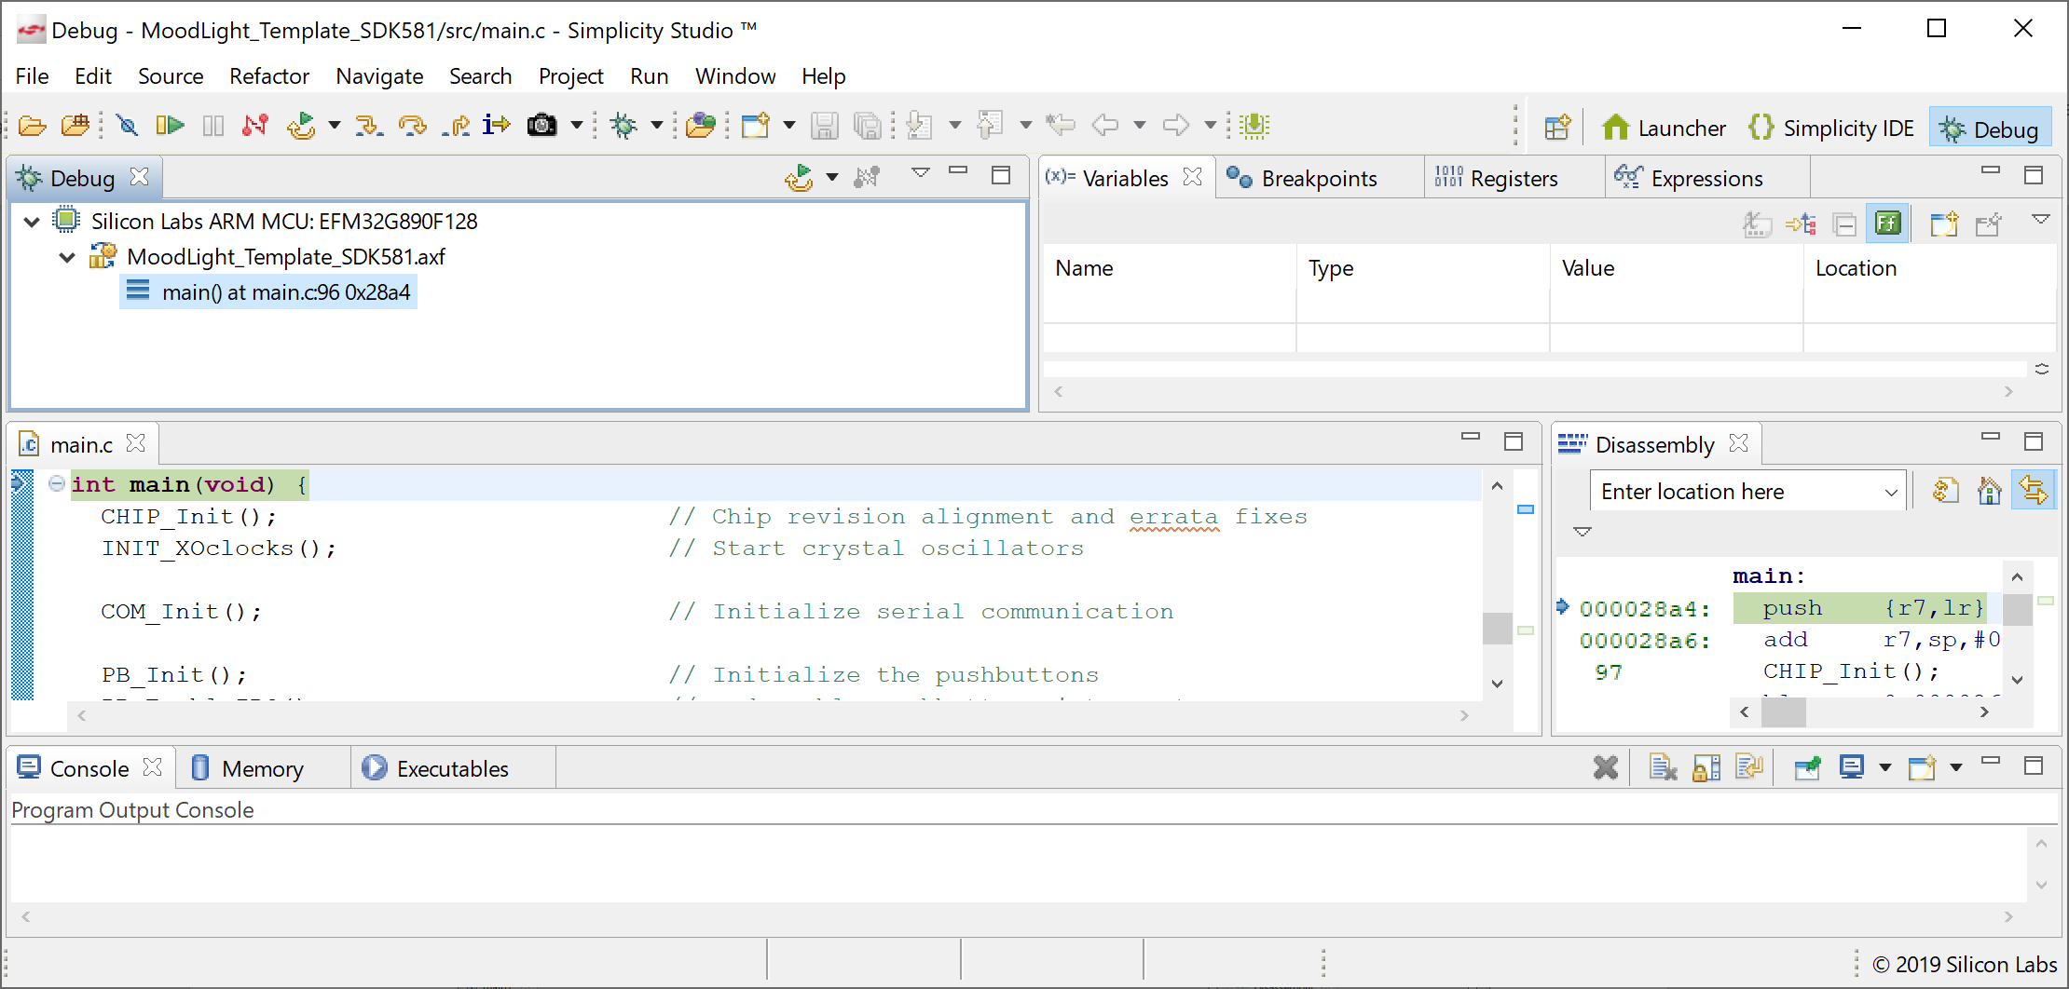

1. The program can now be started with the “Resume” icon in the main menu:

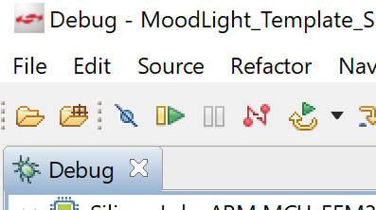

The program should now run on the STK board and LCD should display the text “idle”.

1. When you wish to end a debug session, the debugger can be disconnected with the “Disconnect” icon:

